Equipment - Chrisleo Botha

Club Liaison and

Newsletter - John Lees

**Southern Cape**

**Nomads Golf Club**

**The Nomads Creed**

*No man is an island entire of itself;*

*Every man is a piece of the continent, a part of the main;*

*Any man’s death diminishes me because I am involved in mankind.*

*And therefore, never send to know for whom the bell tolls;*

*It tolls for thee.*

***Captain Christo***

**May 2023 Newsletter**

**Plettenberg Bay 21st May 2023**

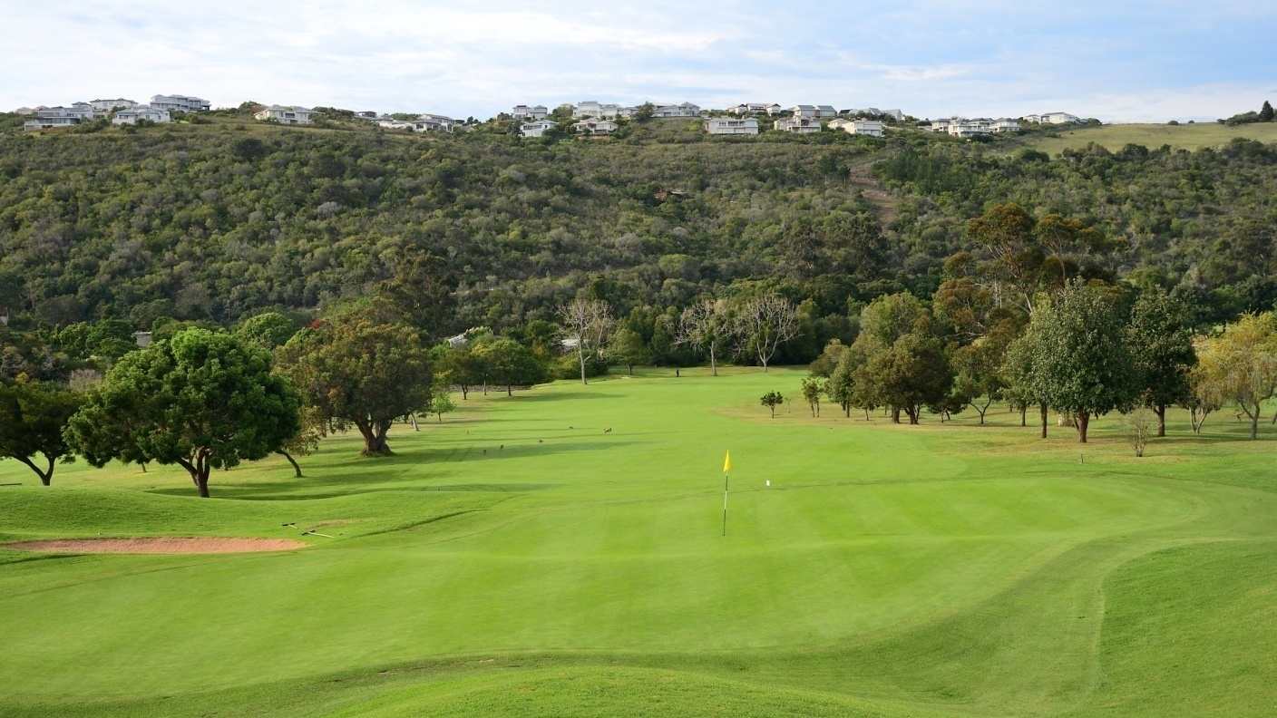

**The beautiful Plettenberg Bay course.**

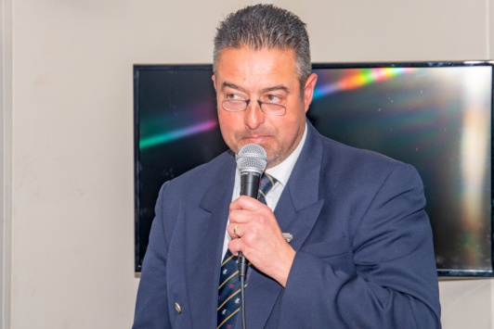

**CAPTAIN’S REPORT MAY 2023**

Good morning all-herewith my report for May

The weather gods was against us at Plett on Sunday and in hindsight the game should probably have been cancelled but I must say that the spirit amongst the guys was excellent and we all had a great time in the end!!

I want to thank the guys that came out to play and gave their all!!

I also want to urge our members to download the Samson App on their phones and if you don’t know how-please ask someone to help you. The guys who already downloaded it-please motivate the guys you play with and haven’t done it to do it asap; it is a really helpful app.

Dominik is also doing a great job with social media-thank you very much. To all our members-if you do have a Facebook account-please go and follow, like and share our Facebook page-we need to get the public more aware of what we as Nomads do and stand for.

If any of our members think that they would like to contribute to our club-please make yourself available to get onto the committee as we want to try and get guys who wants to stand for JVC next year to have about a year’s experience on the committee so that he will know exactly what to expect.

Our next game is at Simola on the 11th of June and I really hope that we have a full field of players as Simola has given us a really good rate to play and we don’t get a chance to play their often.

Good luck to Nick and Fanus with their Seaboard and Andrew Mentis games-it looks like everything is getting together very nicely and I know it is going to be a BIG one!!

See you all at Simola!!

Yours in Nomads,

Tjoepie Pretorius

**Our National Sponsors**

 



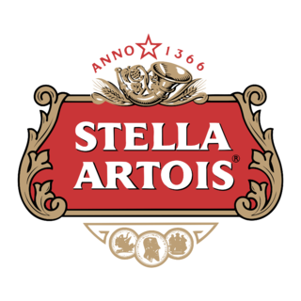 

Please support our National Sponsors

**Match secretary’s report for Plettenberg Bay**

**We had a field of 39 players consisting of: 31 Southern Cape Nomads, 3 visiting Nomad 2 prospective Nomad and 3 guests.**

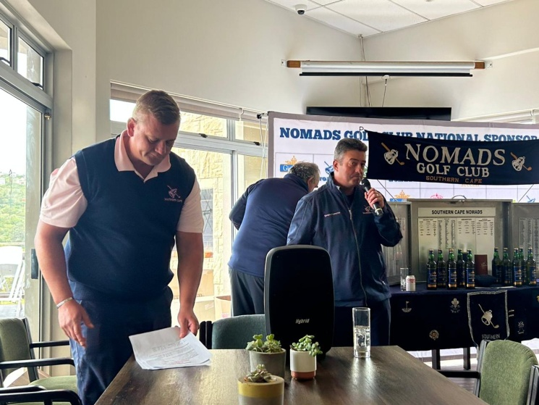

**Quick prizegiving**

**Monthly Game Prize Giving at Plett**

**A: Jason de Boer**

**B: Andy Duncan**

**C: Fanus Truter**

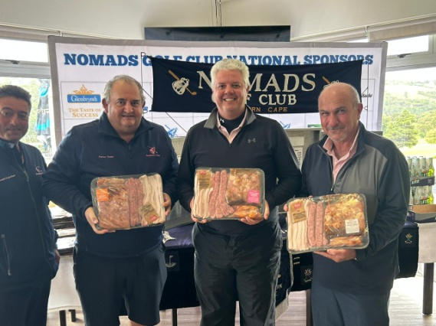

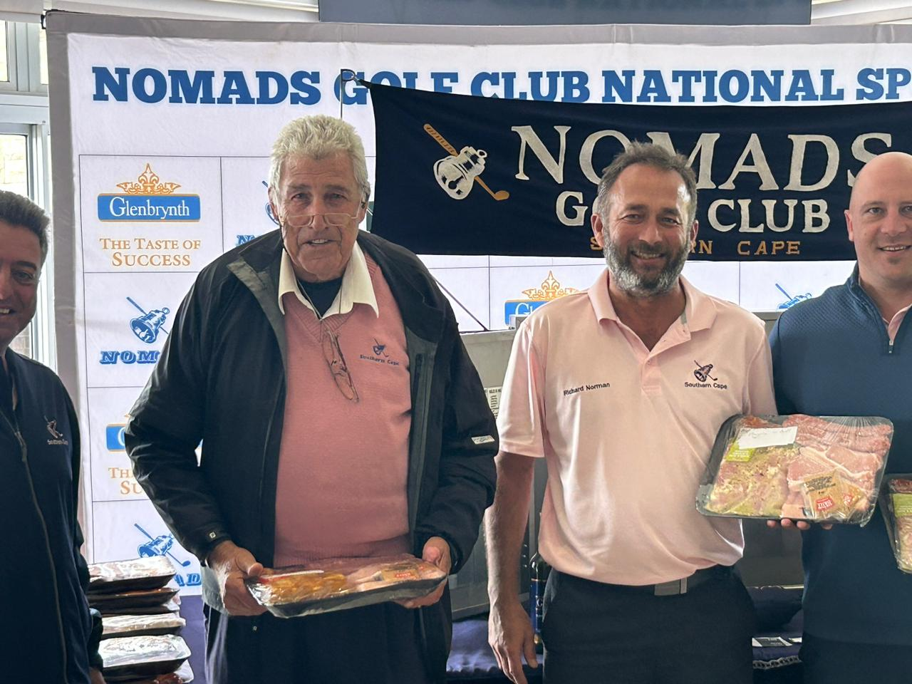

**Best playing fourball:**

**Etienne Englebrecht, Richard Norman, Dominik Dimatellis**

**Drawn fourball:**

**Eugene Barnard, Tjoepie Pretorius, Lee Lippiat, Dominik Dimatellis**

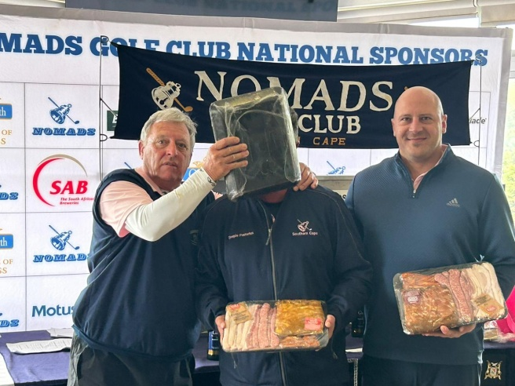

**Over 55 winner:**  **Fanus Truter**

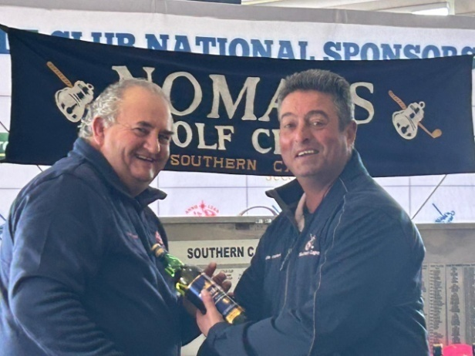

**ll , 12th Ken Spencer, 14th Marnus again.....!! .**

**Worst playing fourball:**

**Andrew Moolman, Ian Botha, Leon Coetzee and Mark Burmester: 37 points**

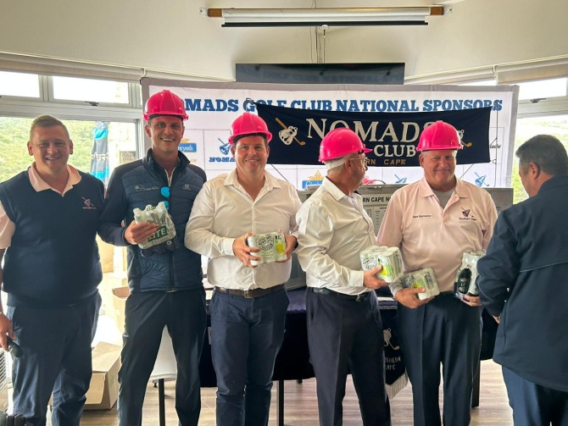

**Best playing pair:**

**Fanus Truter and Andy Duncan**

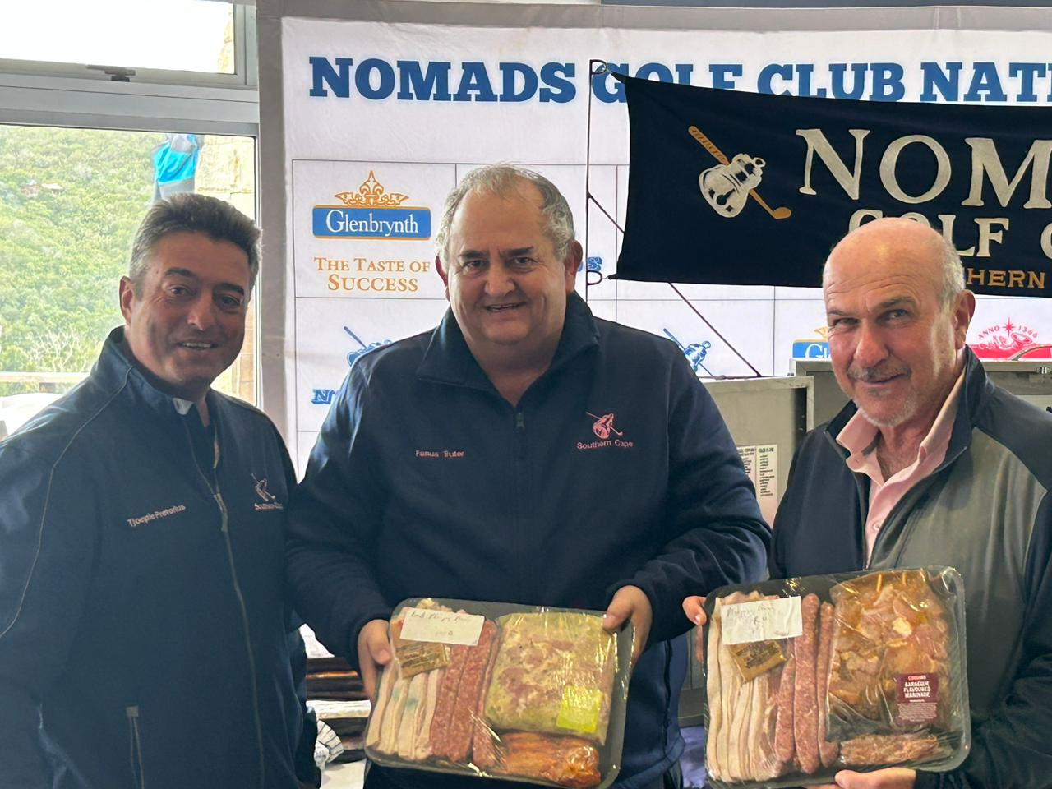

**Glenbrynth Whisky Winners**

**1 bottle Fanus Truter, 2 Bottles Barry Danvers, 3 bottles Boetie van den Berg**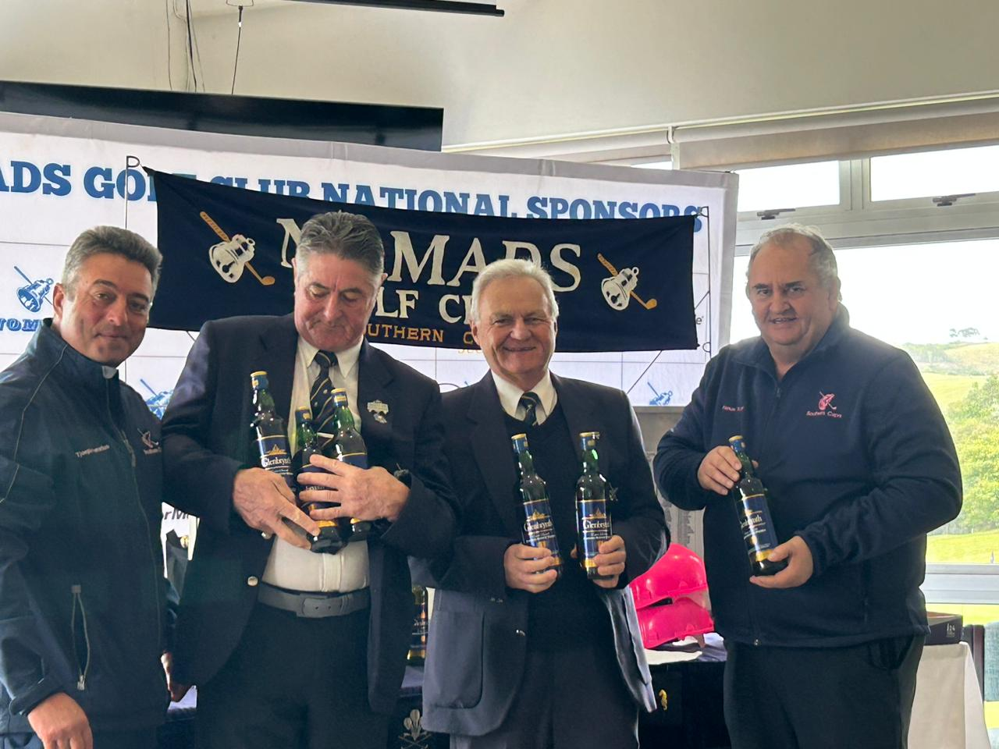

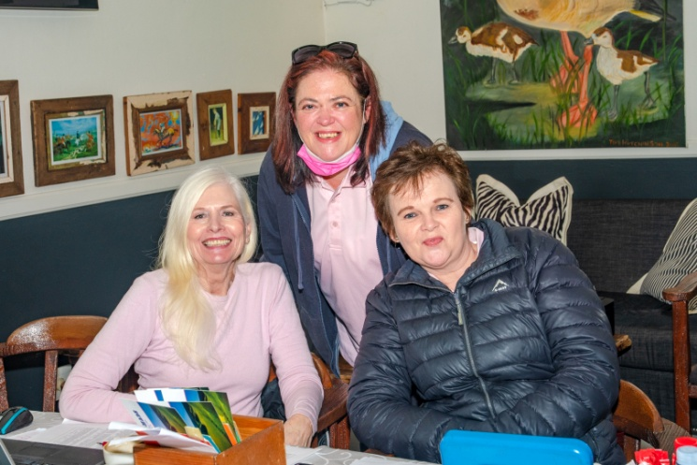

**Thank you to our lovely “Pink Ladies”: Berti, Bets and Liezl without whom, Nomads could not exist.**



**A very Happy Birthday to for those having birthday’s in June: 5th Malcolm Butlin, 7th Frankie Brown, 9th Berti Harris, 10th Andy Duncan, 10th Andries du Preez, 13th Danie Conradie, 13th Fanie du Plessis, 13th Andre van Greunen, 15th Mike Hargreaves, 16th  Jason de Boer, 22nd Arthur Ambrose, 23rd Riaan Burger, 25th**

**Nomads Golf Club Southern Cape**

**Playing Calendar 2023**

January 22 Mossel Bay

February 19 Kingswood

March 26 Pinnacle Point

April 23 Knysna

May 21 Plettenberg Bay

June 11 Simola

July 9 Goose Valley

August 5 Mossel Bay Andrew Mentis

August 6 Pinnacle Point Seaboard

August 7 Mossel Bay

September 11 Kingswood

October 15 Oudtshoorn

November 12 Pezula

December 3 George – Gold Cup

**Captain Tjoepie Pretorius Vice Captain Nic Nieman Junior Vice Captain Fanus Truter Immediate Past Captain Peter Leibbrandt Secretary Christo Langenhoven Treasurer Chrisleo Botha Match Secretary Berti Harris Membership Flats Huisamen Handicapper Frankie Brown Furtherance of Golf Dominik Dimatellis Sponsorship Fanus Truter Equipment Officer Jacques Theron Away Tours Dave Meyer Golforama Leon Coetzee Newsletter Austin Graves Club Liaison John Lees Website Eric Nelson**

**Communications Dave Meyer**

**Our next game in will be at Simola on May 11th June 2023**



**See you on the tee! Happy golfing**

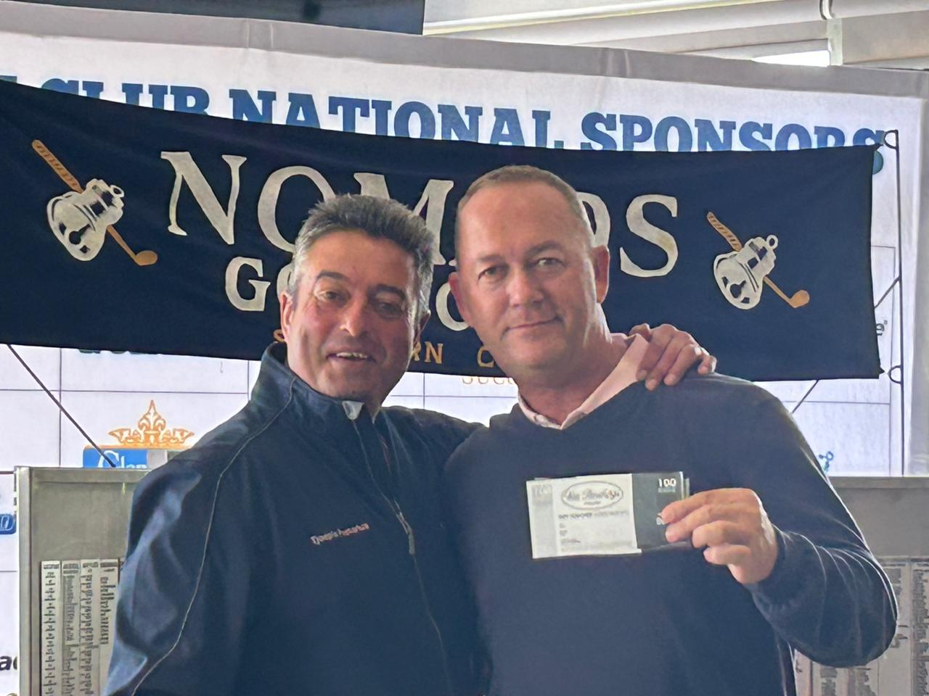 **Van Rensburg’s voucher Dave Meyer**

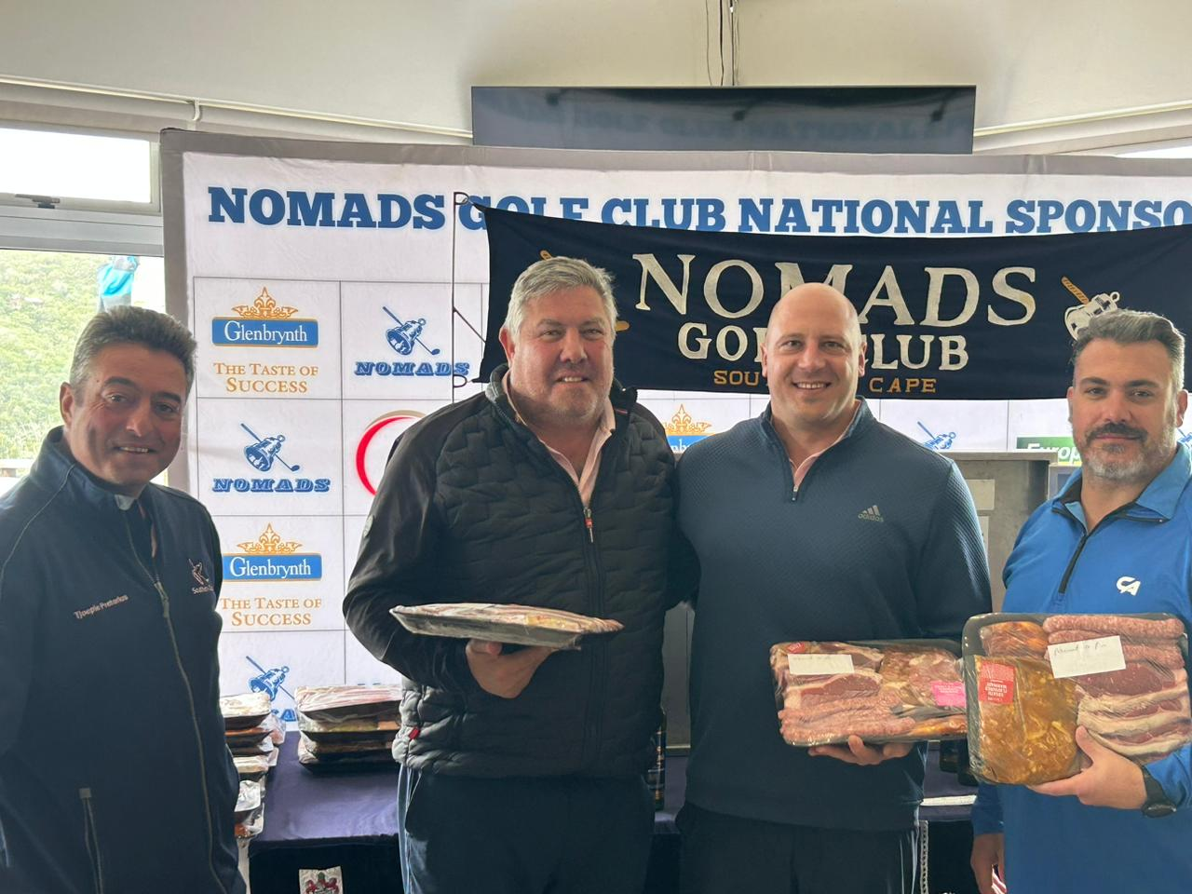

**More winners**

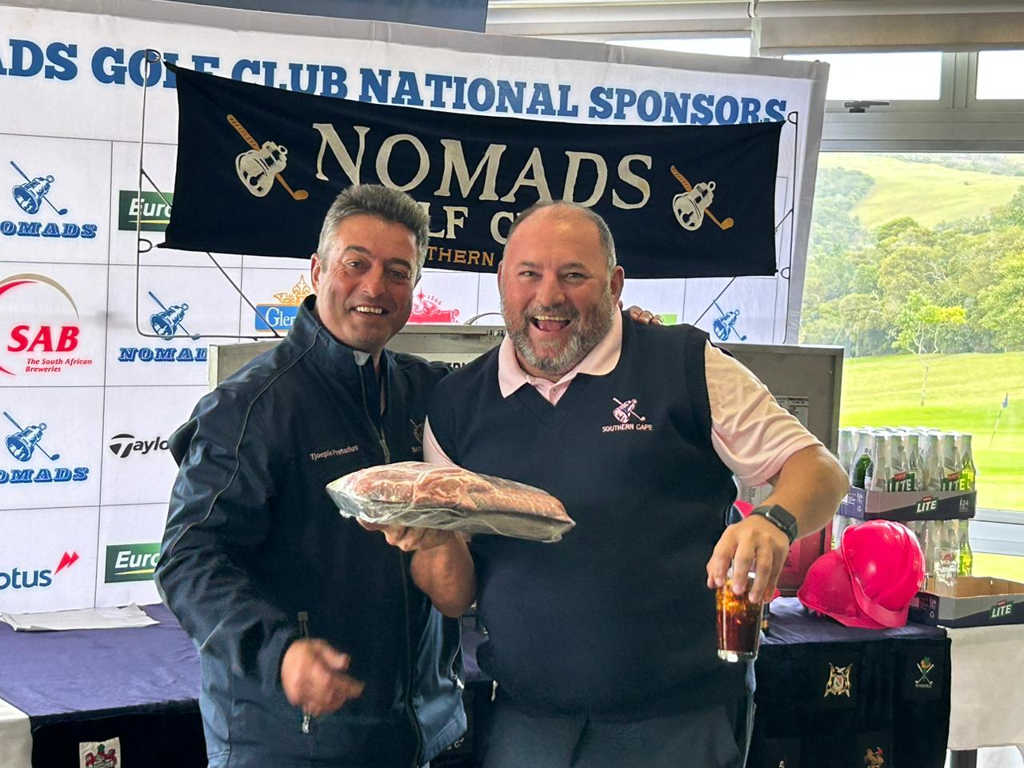

**Matchbox winner: Nols Viljoen** 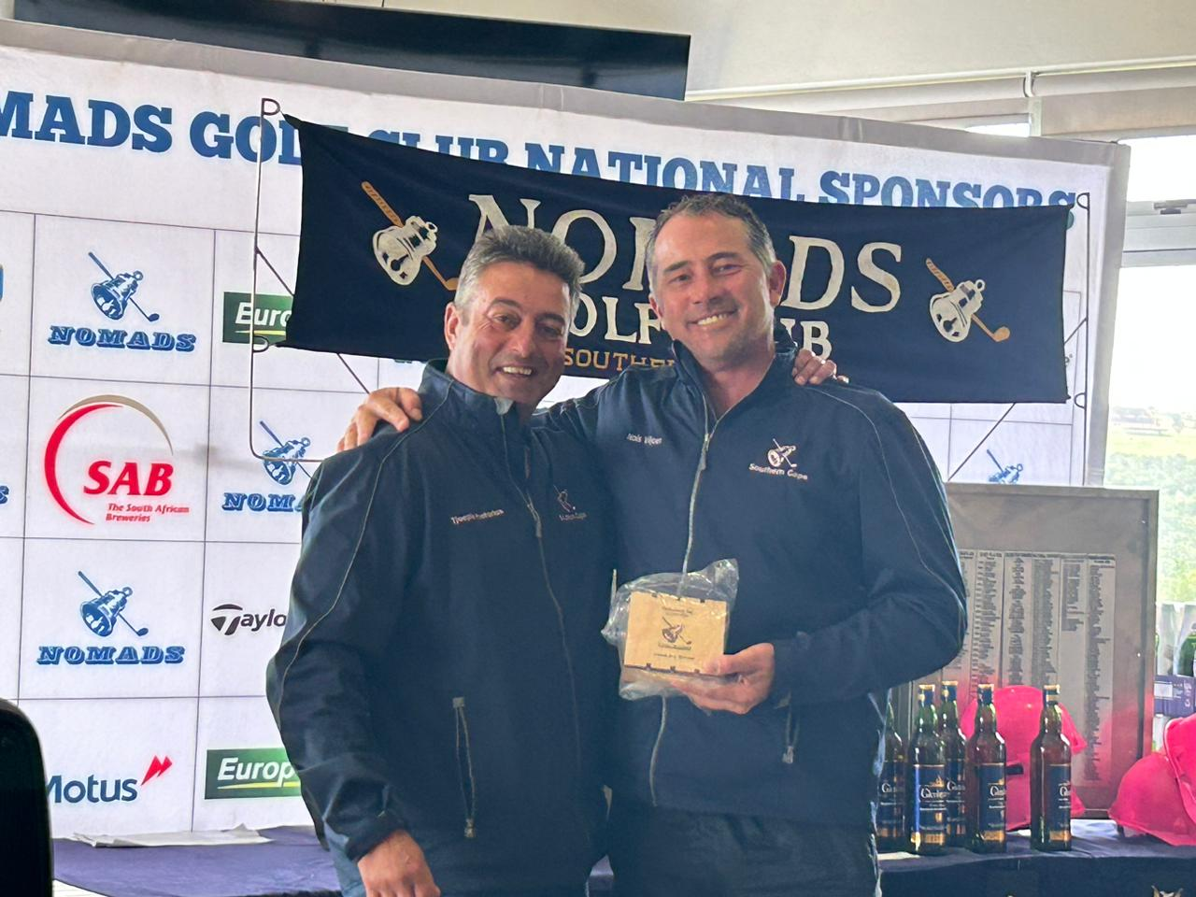

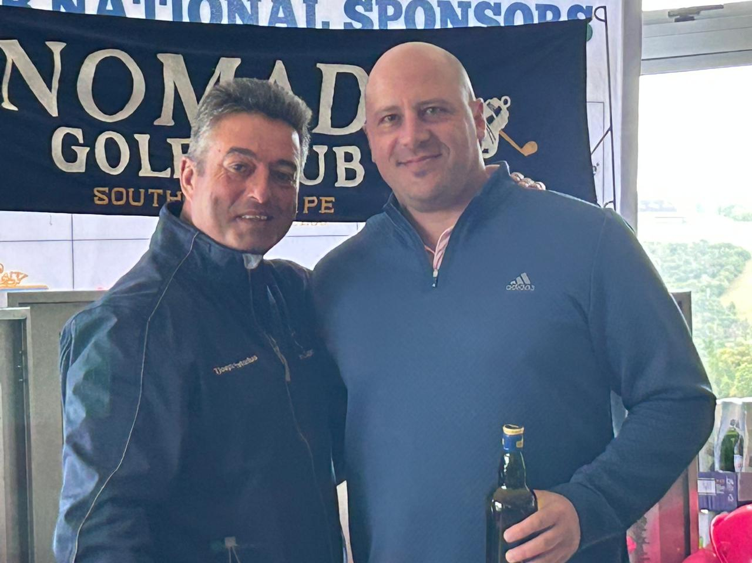

|  |
| --- |
|  |

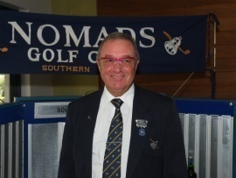

***Golforama Report for May 2023***

Allow me to deviate from my normal format this month.

During our journey through life, you meet many people who have a positive impact on your life and those around them.

Such a person was Derek Botha, a non-Nomad, but an active Golforama volunteer. I believe Derek would have become a Nomad, if it wasn’t for his ill health.

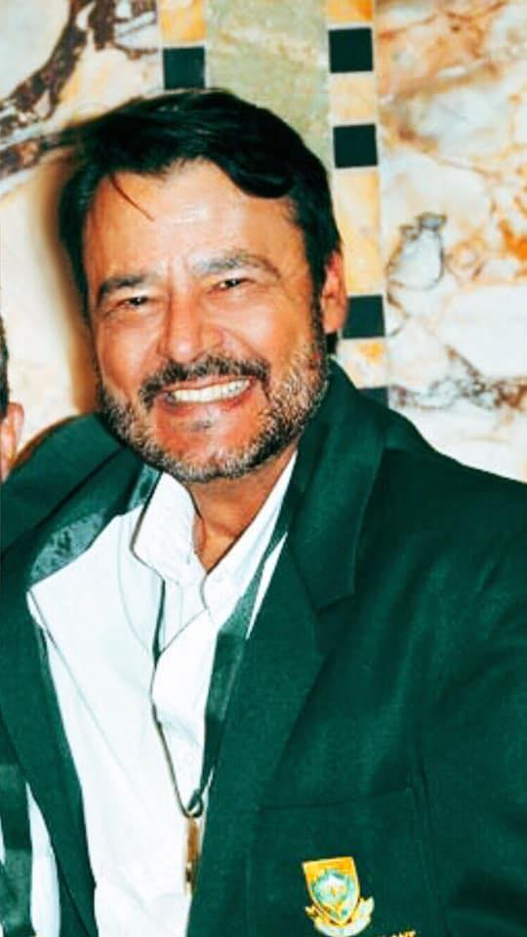

Martin Te Groen brought Derek into the volunteer pool last year for the Vodacom Origins Final and he did all the days as well at Dimension Data earlier this year.

This is an excerpt of an article which appeared in the George Herald recently.

“Heart transplant recipient and avid golfer Derek Botes (58) participated in the World Transplant Games in Perth, Australia earlier this month and brought home a gold and silver medal.



He was selected to represent South Africa as an official transplant team member and received his national colours approved by SASCOC.

Derek won gold for South Africa in his doubles match on Monday 17 April and silver for in the individual stroke play game on 19 April.”



After returning from the triumphant trip to Australia, Derek went and played in the converted ”Jock of the Bushveld” tournament in Nelspruit, which he won.

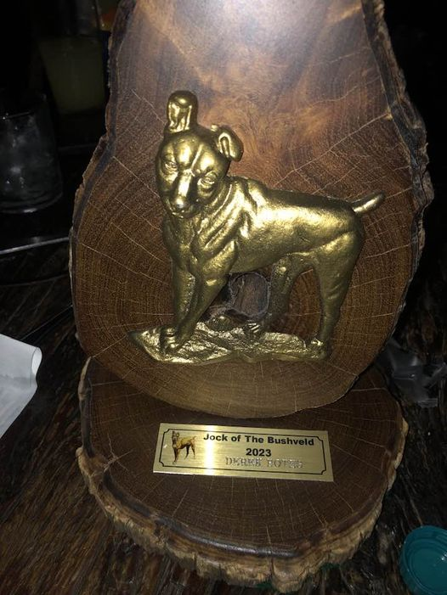

Sadly, Derek passed away in his sleep, the same night.

Rest in Peace my friend, thank you for being part of my team.

The next tournament on the Sunshine Tour calendar, will be the SunBet Challenge, hoisted by Sun City at the Gary Player Country Club from the 30th May to 2 June 2023.

On a lighter note, happy birthday to our own famous Dean Burmester on the 2 June 2023. Happy, happy Champ!

